The campaign works only for IL2FB+AEP+PF merged installs patched to version 4.04m.

Please install "Bushpigs" folder into your Campaign/RA folder thusly-

X:\Program Files\Ubi Soft\IL-2 Sturmovik Forgotten Battles\Missions\Campaign\RA\Bushpigs

where "X" is whatever drive your game is installed on (usually "C")

Please cut/copy the whole “Bushpigs” folder to your desktop and then place the whole folder as above

To play the campaign, please select RAAF as nationality and then "Bushpigs" from the
list.

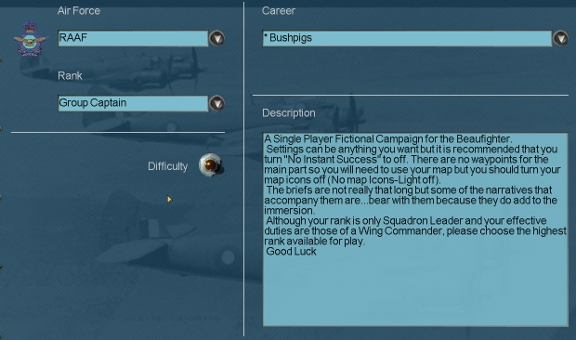

The campaign was built with and the settings are recommended are as follows –

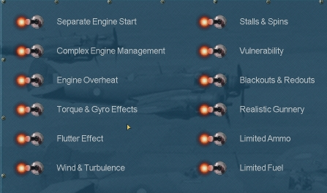

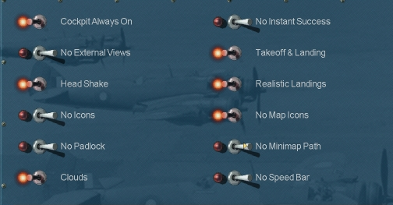

But you can play with any. I recommend that “No Map Icons” and “No Minimap Path” are selected as above though.

Also it is recommended that you turn your markings off on the arming screen.

Please follow the briefings closely

Also note that the time frame for this would be late 1943 or early 1944. Although the game equips us with what appears to be a DAP Beaufighter, let’s assume that it is an earlier import Bristol.

Thanks to all my various testers amongst the Hellhounds and Dangerdogs.

You may lose some of the AI cast along the way. Unfortunately it happens sometimes. Unless the narrative tells you that they died, assume you were hallucinating.

Feedback of any sort please to keirondalle@shaw.ca

Thanks for playing one last time.

Dubbo

